# Riphah School of Computing and Innovation (RSCI), Lahore



## 3rd Semester

## Assignment 1

**Submitted to:** Ms. Amna Bibi

**Student Id:**

53457

**Student Name:**

Muhammad Abdullah

BSCS-3B

04-11-2024

**Computer Organization & Assembly Language (Theory)**

**QNo1. Explain the stored-program concept introduced in the IAS computer. Why was it a ground breaking development in computer history?**

**Ans: Stored-program concept** was introduced by the **Institute for Advanced Study (IAS) and** was designed by John von Neumann and his team. It is a fundamental principle in computer architecture. This principle says that a computer program (instruction. Whereas in earlier computers we required external configurations such as rewiring, to change the program.

**Why it was Groundbreaking:**

The stored-program concept was revolutionary because it **enabled general-purpose computing**. Before this, computers were programmed for specific tasks only. Each computer requiring physical changes for each new function. With the stored-program model, computers could load any program and switch between tasks by simply loading a new set of instructions into memory. This advancement led to:

1. **Increased Efficiency**
2. **Scalability**
3. **Foundation for Modern Computers**

All the modern computers that are being manufactured in modern world have the basic layout of IAS computer that was basically manufactured almost 75 years ago.

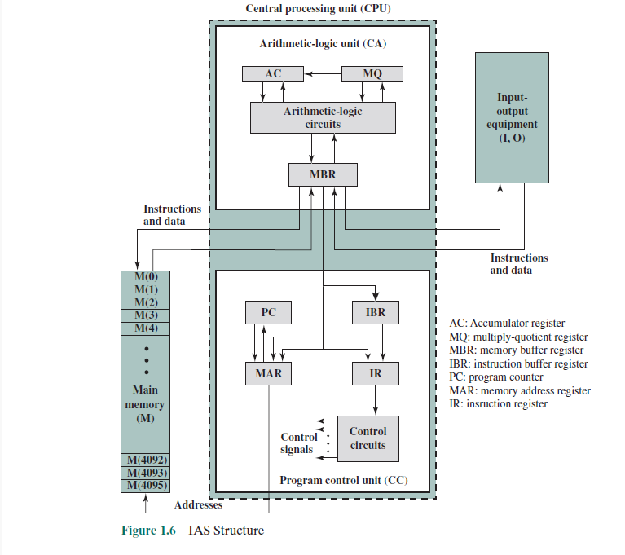

Figure : IAS Structure